Policy Name | Financial Conditions and Activities
Policy Number | EL – 5
Policy Type | Executive Limitations (EL)
Last Approved | March 29, 2023, and Audit May 2023
Board Review | Internal – Twice Annually - March & November  Externally – Once Annually - May

With respect to the actual ongoing financial conditions and activities, the Executive Director shall not knowingly cause or allow the development of financial jeopardy or a material deviation of actual expenditures from Hospice PEI priorities established in its Ends Policies. Executive Directors Interpretation (and justification as to why it is reasonable)
- I interpret this to mean that the Executive Director should ensure good financial controls are in place and monitored and revenues are used for the work we do as defined by the ends policies which informs how we do our work and for whom.
- I should not cause any financial jeopardy intentionally or not by uninformed of potential financial issues.
Data (new data in red)
- Purchase orders are required for any expenditure and are reviewed and approved by the ED.
- I keep tack of all banking accounts and investments regularly.
- I receive notifications when credit card transactions happen.
- There is only one credit card. Used only by the ED.
- Administrative staff are only authorized to make purchases such as online office supplies or client support resources once a PO has been submitted, reviewed and then approved. I receive a notification immediately.
- We are using an external payroll service (Ceridian) who processes payroll and CRA remittances with updated information from the organization. Payroll is processed every 2 weeks. The process is to submit any changes and or confirm of regular payroll by the ED and sent to the bookkeeper who submits to the online platform in Ceridian. Ceridian then sends the ED an email saying it’s been submitted for review. I conform with bookkeeper the review that its correct and it is then confirmed by the bookkeeper and the final submission is processed through Ceridian. The Bookkeeper prints off payroll reports and are filed for auditing purposes. Staff receive a confidential payroll stub that is mailed out and distributed to staff on payroll week.
- Cheques require 2 signatures, along with all documentation for review from signatory to verify what the cheque is written for. I continue to process some remittances through our online banking or with the credit card which is paid off every month.
- An external audit is completed once a year. Auditors receive all bookkeeping files, expense files and journal entries from bookkeeping files.
- All expenses require a detailed receipt along with the PO.
- New data: We have hired a financial administrator that has added extra oversight to financial transactions and supports maintaining best practices for recording financial transactions and activities.
The auditor has requested we track separately receipted and non receipted tax receipts to support scrutiny CRA demands through external auditing processes.

I report compliance.

The Executive Director has a supervisory role over all aspects of the Association’s financial management. The Executive Director may delegate these responsibilities as they see fit. Executive Directors Interpretation (and justification as to why it is reasonable) (No changes to interpretation since last reporting period).

- I interpret this to mean I can choose to assign financial management task to anyone if I supervise the activity/tasks.
Data new data in red.
- See above.
I report compliance.

Further, the Executive Director shall not:
1. Permit tax payments or other government ordered payments and government filings to be overdue or inaccurate.
Executive Directors Interpretation (and justification as to why it is reasonable) (No changes to interpretation since last reporting).
I interpret this to mean CRA payments are to be paid on time.
- Tax filings are to be filed on time.
Data no new data
- Tax filings were filed by the external auditor as a part of their auditing services. There are signed copies on file.
- Ceridian submits CRA remittances every payroll.

I report compliance
2. Expend designated revenue for other than the purposes intended by the donor, funder, or partner that provided the revenue.
Executive Directors Interpretation (and justification as to why it is reasonable) (No changes to interpretation since last reporting).
- I interpret this to mean I do not use restricted funds that have been designated for a specific purpose identified by the designated revenue.
Data (no new data )
- The only restricted funds the organization has from a donor is the Florence Simmonds Bequest. It states that funds we receive annually and is not to be used for salaries or Capitol Costs. Other costs that are not related to salaries uses the revenue from this source. The total amount of other costs of the organization that is not related to salaries is above the amount we receive.
- Any donations made through our Canada Help platform allows the donee to designate where they would like their donation to go. The vast majority say ‘where resources are needed most’ or it is left blank. I print off the reports monthly.
- There are currently two other restricted funds that are internal. They are the Community Foundation fund that is to cover the costs of closing operations if we needed to. The other is the savings account which is used to put money in to earn interest. We used GIC investments in the past. I can transfer money in but need to let the board know to remove it to cover operations. It has only been restricted internally and the money in the account that has been donated has not been given a restriction by the done.
I report compliance.
- Fail to settle payroll and debts in a timely manner.
Executive Directors Interpretation (and justification as to why it is reasonable) (No changes to interpretation since last reporting).
- I interpret this to mean payroll other payables such as staff expense claims are paid regularly (every two weeks) and all debts are paid as soon as an invoice is received.
Data (new data)
- Payroll is submitted biweekly. Using Ceridian who generates email reminders to complete submission.
- There has been no request from staff requesting why payroll has not been deposited.
- There are 3 steps involved in ensuring payroll is submitted on time 1) review and sign off paperwork from bookkeeper, 2) Bookkeeper logs in to online payroll accounts and submits, and 3) submitted to Ceridian.
- All ROEs have been submitted as per required no later than 5 days after last day of employment.
- All invoices are coded and placed in the bookkeeper file for processing once a week. ED meets with bookkeeper every Wednesday in person to review paperwork for filing in provincial office. New Bookkeeper works on site once a week. All documents and laptop kept on site.
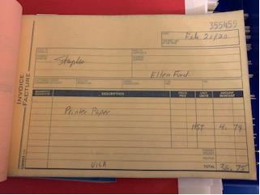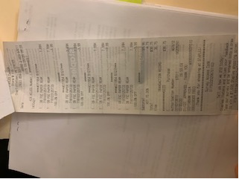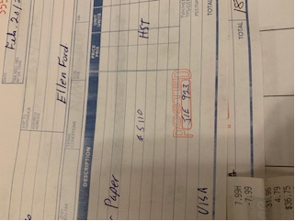
Sample of PO submitted, receipt then attached, verified and assigned journal entry
Payroll generated and verified then entered for coding in bookeeper ledger Above and below Staff HR handbook re renumeration

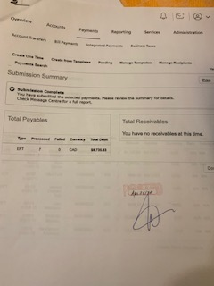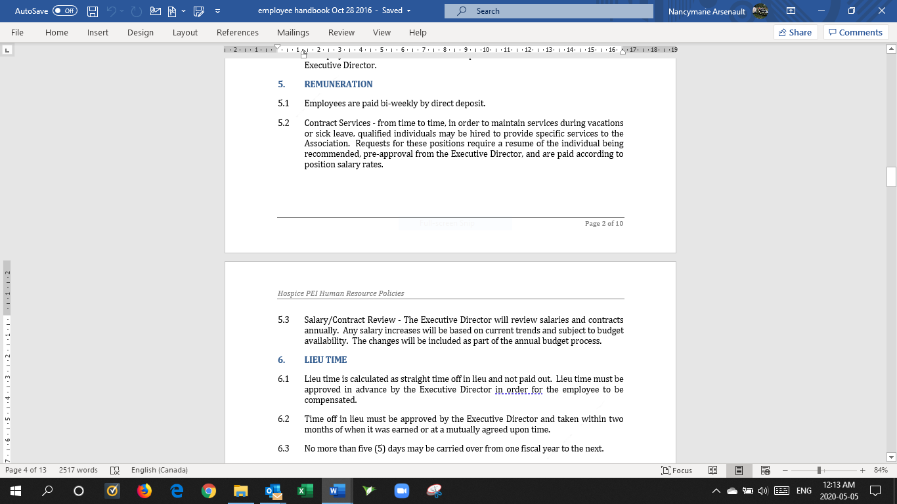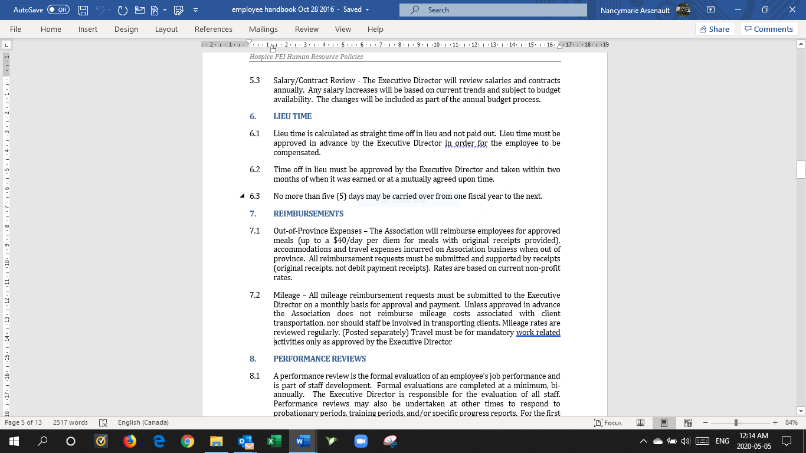
I report compliance
- Fail to aggressively pursue receivables after a reasonable grace period.
Executive Directors Interpretation (and justification as to why it is reasonable)
(No changes to interpretation since last reporting period)
- I interpret this to mean any money owing to the organization is collected within a reasonable amount of time.
Data (No data in red)
- Except for membership renewals Hospice does not pursue payments to the organization as there is no need since we are not a fee for service, nor do we provide items for sale.
- Membership renewal letters are sent out once a year in March. Currently Hospice does not pursue people who do not renew membership. Membership information application and fees have been added to the website.

I report compliance
- Make purchases or commitments without due consideration to quality, servicing, value for dollar, and opportunity to fair competition. In addition, the Executive Director shall not:
Executive Directors Interpretation (and justification as to why it is reasonable)
(No changes to interpretation since last reporting).
- I interpret this to mean I get the best value for any purchase and do comparable shopping. For example, for office supplies I purchase non brand names if the quality is just as good as name brands. IE, paper, post its, pens etc.
Data new data in red
- Many PO’s would demonstrate I make purchases often at dollar stores for supplies for the office, volunteer retreats etc.
- There is only one lease we currently have. That is for the photocopier. This has eliminated the need for all Charlottetown staff to have desk top printers (saving dollars) and has allowed us to do bulk copying for all locations at a lower cost than sending it out for external printing.

I report compliance

- Make any capital acquisition, capital repair, or enter into a supply or service contract budgeted or unbudgeted, of $5,000 or greater without obtaining three comparative quotes, where available.
Executive Directors Interpretation (and justification as to why it is reasonable)
(No changes to interpretation since last reporting).
- I interpret this to mean I do not make a purchase, agree for a contacted service or make any acquisition that is over $5,000 without getting three quotes.
Data no new data.

I report compliance

- Commit the Association to a payment period greater than the useful life of an asset.
Executive Directors Interpretation (and justification as to why it is reasonable) (No changes to interpretation since last reporting).
- I interpret this to mean I do not purchase an item or obtain an asset that has a payment period greater than the value of the product.
Data no new data
- The organization only has re occurring payments for telephone services and internet and the lease of the printer.
- I report compliance

- Make a single purchase or commitment of greater than $10,000 without Board approval. Splitting a purchase or commitment to avoid this limit is not acceptable.
Executive Directors Interpretation (and justification as to why it is reasonable)
(No changes to interpretation since last reporting).
- I interpret this to mean I do not make a purchase or commitment to spend on anything that is greater than $10,000 without asking for Board approval.
- Splitting the spend is not allowed.
Data no new data
- I have not made any purchase for the value of $10,000 or more.
I report compliance

- Fail to disclose annually to the Board all contracts valued at $5,000 or more per year. Executive Directors Interpretation (and justification as to why it is reasonable) (No changes since last reporting)
- I interpret this to mean I should not notify to the Board that I have engaged in a contract that is valued at $5,000 or more in a year.
Data no new data
- There have been no contracts that I have signed or committed to that is valued at more than $5,000 per year.
I report compliance

- Fail to hold a percentage of easily liquefiable net assets to provide continued funding of operations should the Association experience a temporary deficit or in the unlikely event that the decision is made by the Board to dissolve the Association or to fund costs related to defensive and/or offensive litigation activities.
Executive Directors Interpretation (and justification as to why it is reasonable)
(No changes to interpretation since last reporting).
- I interpret this to mean that I have in a contingency fund an amount of funding for contingency planning resulting from a temporary deficit of revenues or dissolvement of the organization.
Data (new data in red)
We continue to have a savings account that I have not needed to access even though I had a request to the Directors over a year ago. We also have the funds in the Community Foundation. I have not received an updated report since the amount reported in the audit.
- Acquire, encumber or dispose of real estate without Board approval.
Executive Directors Interpretation (and justification as to why it is reasonable)
No changes to interpretation since last report
- I interpret this to mean I should not buy or make agreements on real estate without Board approval.
Data (no new data)
- Hospice PEI has 5-year lease agreements for office rental at 119 Water Street Charlottetown. Hospice PEI does not own property. We are going into our third year in January 2024.
I report compliance
- Authorize cash funds to meet operational requirements without strict control over its use, custody and safekeeping in detailed procedures and guidelines.
Executive Directors Interpretation (and justification as to why it is reasonable)
No changes since last reporting
I interpret this to mean I shall practice good financial controls such as ensuring practices on collecting revenue at fundraising events are followed, staff who have a petty cash keep track and provide receipts, banking is monitored regularly.
Data: no new data
There are strict guidelines that all volunteers and staff must follow when collecting donations on behalf of the organization.
All money collected is recorded on a sheet that identifies a breakdown of money collected.
It is then tallied and signed by both volunteers or staff.
The person picking up the bag verifies the amounts. It is then placed in a sealed banking bag that is tamperproof.
The bag is signed and dated on the outside by both parties.
The bag is delivered unopened to the main office where the Admin person opens the bag, counts the donation, verifies the sheet, signs the sheet and place it in a file.
The admin then prepares a bank deposit.
Cheques require 2 signatures along with detailed invoices that match the cheque
I receive alerts on banking activity that I have not conducted
I receive google alerts on any fundraising activity that is advertised.
Cash reconciliation and sign off sheet and Process for volunteers working at fundraising events such as Let Their Light Shine.
Staff have petty cash amounts that they can use with discretion for small office purchases, paper, ink, etc. Charlottetown office staff have each a $50 petty cash specific to office supplies re the move to the new location, picture hangers, filing stuff etc. Both EP and WP offices have a 100 petty cash. The petty cash is reconciled at the end of a fiscal year when all receipts are handed in with the balance amount. Petty cash is topped up as needed/requested and when receipts are submitted.
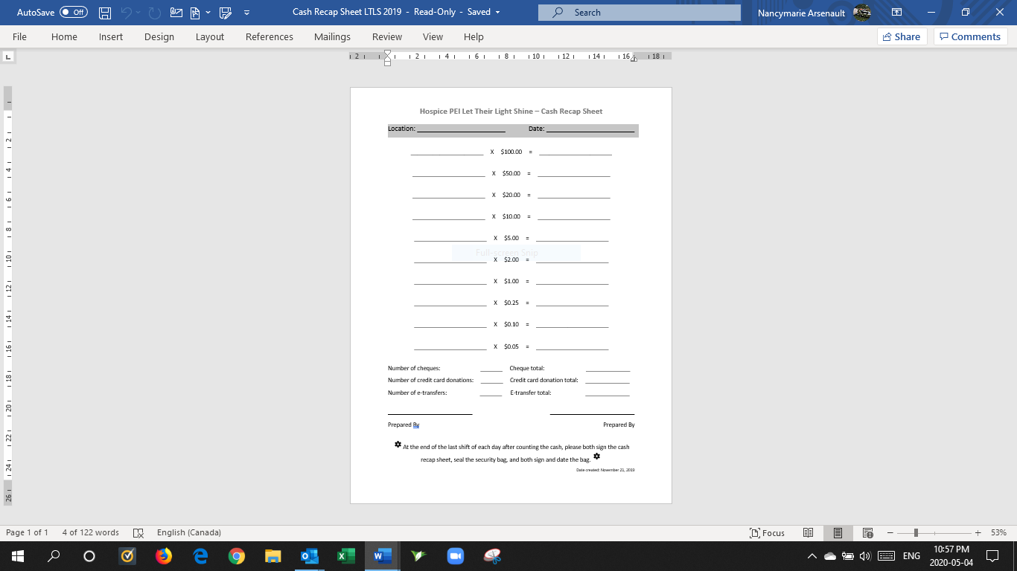
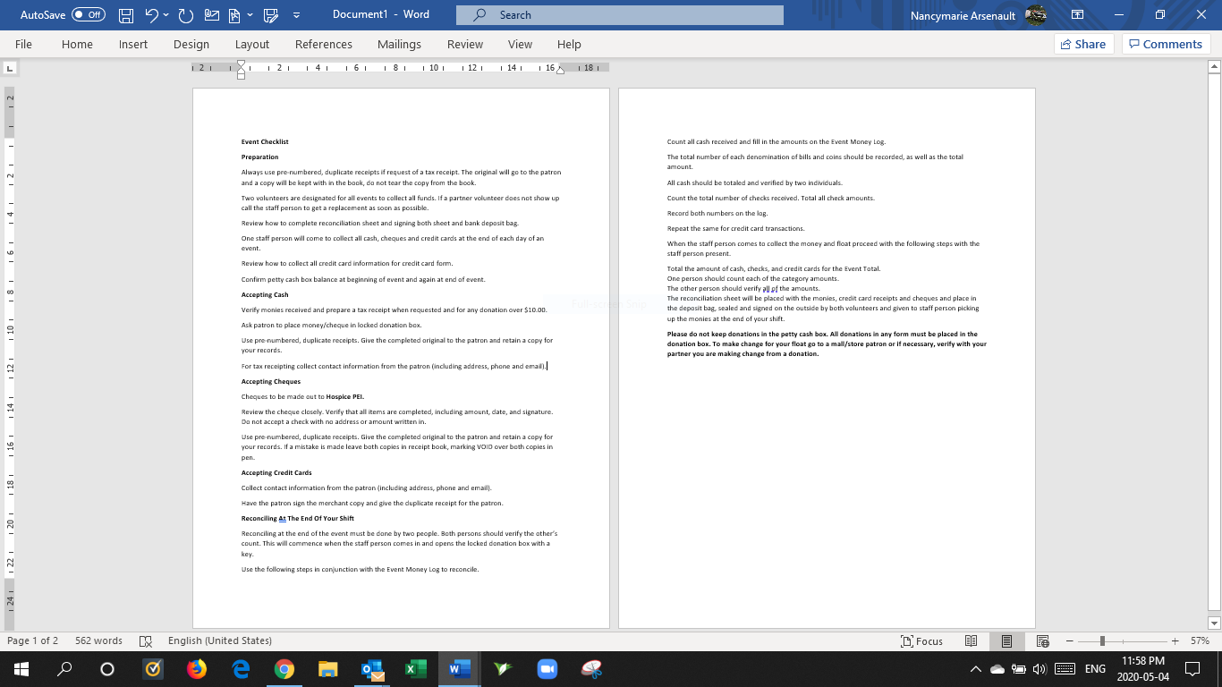
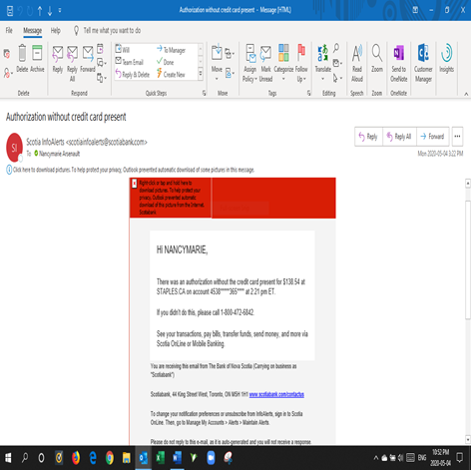
Notifications for banking activity sent by email whenever transaction is made without the card. IE online purchase.

I report compliance
December 11 2024
Last Date Reviewed Signature

no changes
Date Modified

